Reinforcement Learning Notes
Christopher Kalitin

Lex: MIT Introduction to Deep Reinforcement Learning
MIT 6.S091: Introduction to Deep Reinforcement Learning (Deep RL)

Deep = Deep Neural Nets, Reinforcement Learning = Reinforcement Learning
Two different fields joined.

Supervision is required to train, ie. labelling good or bad results.

Supervised Learning: Teach by example. Eg. Image and label, state and proper action
Reinforcement Learning: Teach by experience

Policy: Agent’s Behavior Function
Value Function: How good each action and/or state is.

Model-based learning: Learn a model of the world to be able to predict how your actions will change future states.
Value-based learning: Learn the value of certain states/actions. Learn how good it is to be in a certain state, then use this to pick which state to enter (which action).
Policy-based learning: Directly learn a policy function.

Q-learning: Estimate the value of a state-action pair, estimate future reward. Bellman optimality equation used to update Q. Qt(St, At)

Using the epsilon-greedy policy, you don’t explore all actions. Epsilon = random, approach 0 during training.

Q-Table: States & actions on axis, reward for each one. Obv can’t do this in complex situations, you have to learn it.

Neural Networks are good function approximators.

Duelling DQN: Use two functions to estimate the value of a state and the advantage of taking an action in a given state against all other possible actions.

DQN is off-policy. Approximate Q and infer optimal policy
PG (on-policy) directly optimizes the policy space. Give a reward depending on victory/loss, effectively average reward for all actions.
PG Pros: Converges faster, can learn complex or stochastic spaces, can more easily model continuous action spaces.
PG Cons: Sample inefficient, less stable during training.

Advantage Actor-Critic (A2C):
The actor is policy-based, the critic is value-based and measures how good each action is.

Asynchronous (A3C Async): Train many agents in parallel, have all of them update the weights in real time.

Stanford: Introduction
Stanford CS234: Reinforcement Learning | Winter 2019 | Lecture 1 - Introduction - Emma Brunskill

Sequences of decisions, not single decisions.

Supervised learning uses labels.

Prerequisites:
- Basic Probability and Statistics
- Multivariate calculus and linear algebra
- Loss functions, derivatives, gradient descent, etc. should be familiar
- Markov decision process

Markov Assumption: The present is sufficient information to predict the future. The future is independent of the past given the present. Only applicable to some situations.

Stanford: Markov Decision Process

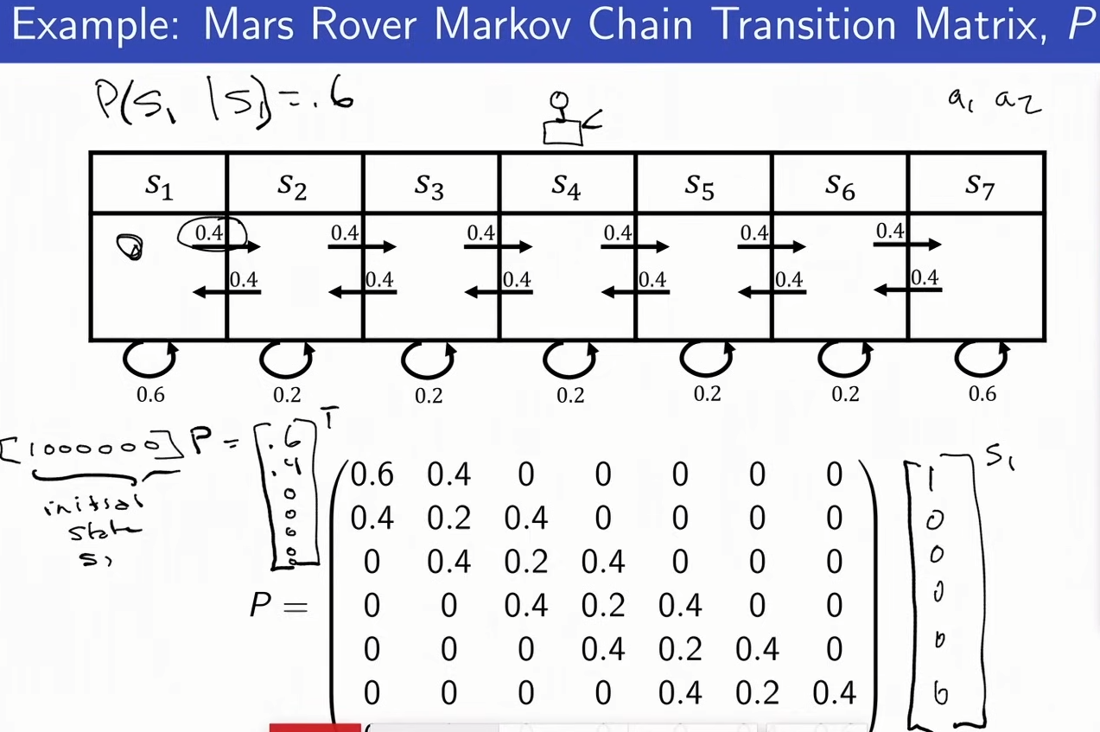
Policy is a mapping from a state to the action you should take.

Value Function: Expected future rewards due to taking an action

State = observation

Markov Property: The information state is a sufficient statistic of history.

The Markov Process is a state of the world and each state has given probabilities for entering an adjacent state. It specifies the distribution of next states that you could arrive in.

The Markov Reward Process gives a reward for each state.

Horizon = number of time steps in each episode, how long an agent is acting.

Return = discounted sum of rewards from current time step to horizon
Gt = rt + y*r(t+1) + y^2 * r(t+2)...

Value function = expected return. Different because the value function can be different from the return function in a stochastic space.

Discount factor doesn’t have to be geometric, but that’s most common.

The value function can be estimated through simulation. Take many episodes and average their returns.

Value function is stochastic while reward function is not.

The Markov Decision Process is just the reward process + actions. Eg. For a state and action pair, give a reward, then transition to the next state. (s, a, r, s’)

MDP is described as a tuple, (S, A, P, R, gamma)
S = state, A = action, P = dynamics/transition model for each action that specifies the next state, R = reward function, gamma = discount factor

Policy is a mapping from states to actions, so the number of deterministic policies is the number of actions to the power of the number of states. Eg. for 2 actions available in 7 possible states, you have 2^7 actions.

The optimal policy for a MDP is not always unique because you can have tied policies in a given state.

Up until now we’ve discussed the value of each state, not the value of a state-action pair. If you value each state for a given policy, you can never take actions outside that policy because you don’t have a value function. Solve this by computing the reward for a state action pair.

More Math Required

Pieter Abbeel 1: MDPs, Exact Solution Methods, Max-ent RL
L1 MDPs, Exact Solution Methods, Max-ent RL (Foundations of Deep RL Series)
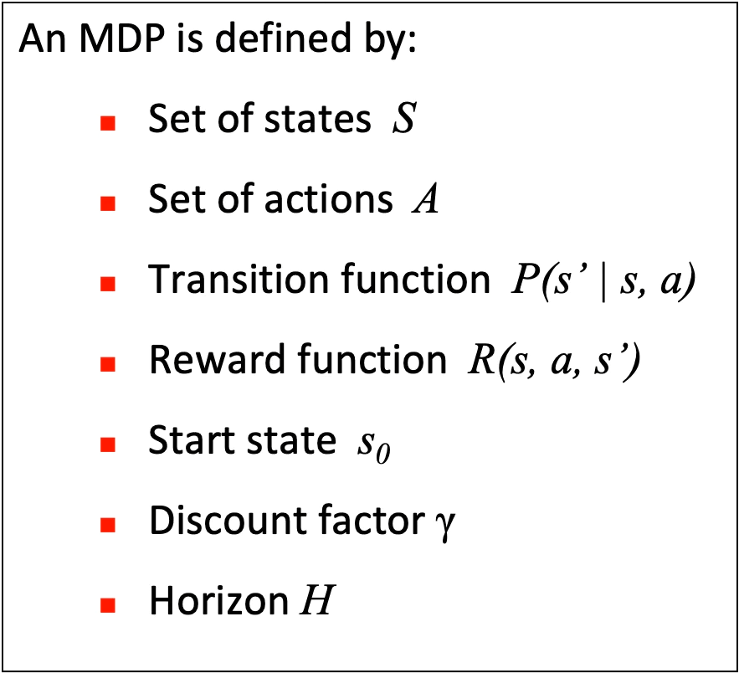
Markov Decision Process is the framework behind reinforcement learning.

Discount Factors:
0.9 = 10 horizon, 0.99 = 100 horizon

Pi symbol = policy

Value Function V*(s):
Maximum expected discounted sum of rewards
Ie. Value of being in a state

Value Iteration:
For each action available in a state, sum the rewards and apply the discount factor. Then, look at the next state and repeat the sum process until you reach the horizon. This is the maximum expected discounted sum of rewards in the future.
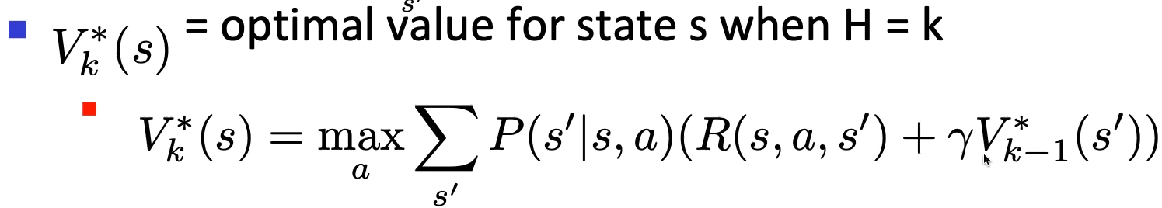

Each step is called a value update / Bellman update/back-up

After enough steps, you converge on the “infinite horizon” value of each state. The true value. Simple convergence.

Q*(s, a) is the expected utility (reward/value) of taking a single given action in a state, and afterward following an optimal policy. Ie. value of a given action in a state.

Q value iteration is determining the value of each action by getting the discounted sum of future rewards.

Policy Evaluation:
Same bellman equation without choosing the max value action? Still converges.
The policy chooses the max value action, not the equation. So no need for the max over a step.
Max in the equation means you’re choosing the next state/action. This is only present in value iteration.

Policy Improvement:
For each available action look ahead one step and find the best action. Train on this.

Maximum Entropy Formulation:
Another way to solve Markov Decision Processes.
Find the distribution of good/bad behaviors.

Entropy = Uncertainty.
Entropy is a measure of uncertainty over a random variable X. The number of bits required to encode X on average.
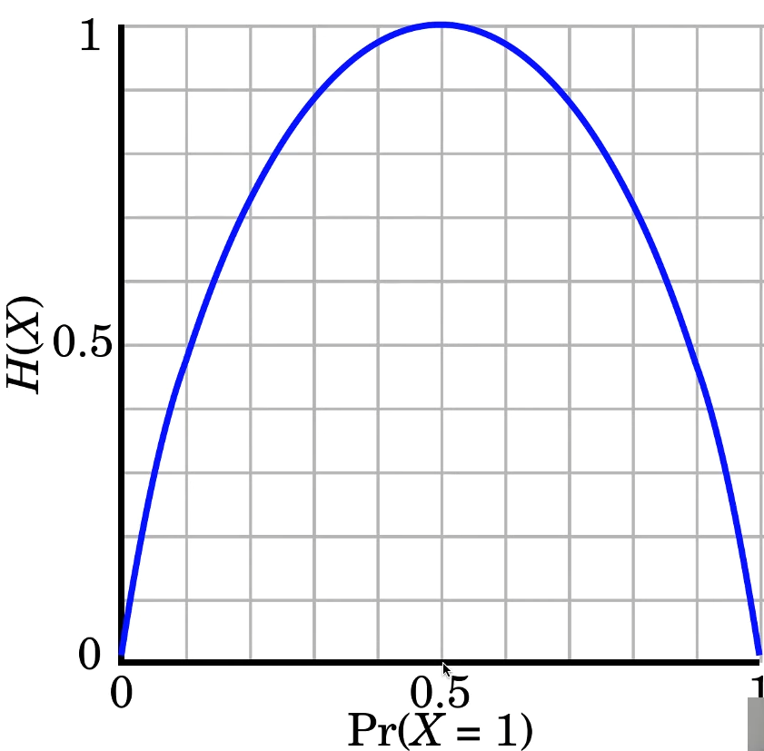
The entropy (uncertainty) is highest when X has a 50% chance of equalling one, and 50% equalling 0. This is the most uncertain case.

Shallower distributions have more entropy. Eg. 10% chance of ten actions (more uncertainty) vs. 91% chance for a single action and 1% for all others.

Max-ent formulation tries to maximize entropy, giving a wider range of actions while still keeping the reward incentive. This leads to more exploration but not a perfect policy.

Apply a softmax on the distribution to get an output action.

The remaining lectures in this series will be on how to deal with MDP that have such a high number of states and actions that the techniques described above are not reasonable.

Pieter Abbeel 2: Deep Q-Learning
L2 Deep Q-Learning (Foundations of Deep RL Series)

What’s a mathematical expectation?

Tabular Q-Learning:
Use samples (state action pairs) to estimate the Q value of an action in a given state.
Q-value is changed by the new reward every step. Ie. previous value is kept & changed.

Epsilon greedy: Instead of choosing the best action sometimes take random action.

Q-Learning converges on the optimal policy even if you act suboptimally. Random actions are suboptimal, but it converges on the optimal policy. This is off-policy learning.

Learning rate is the multiplier on the new target (New target = new Q value, adjustment on previous Q value). High learning rate means a large change, over time you have to decrease the learning rate.
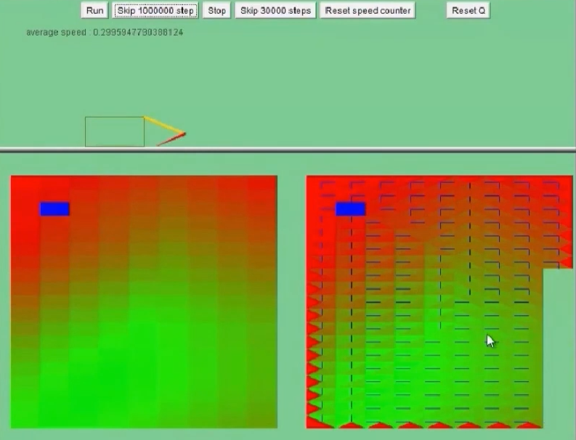
You can see its brain!
Parameterized Q function:
Q_{θ} (s, a) is the parameterized Q function.
Take a state action pair and return the Q-value.

Theta represents the learned parameters in the Q-function.

The Q-function can be a linear function. Eg. how tall is your tallest tower in tetris, Sum total height, etc.

Neural Nets or Decision Trees are used. A loss function is used to nudge the output of the Q-function closer to what the expected reward is.

Multilayer Perceptron:
Stack linear functions and nonlinearity. (Weights and Activation Layer)

SGD + Momentum + Preconditioning is the most common Gradient approach.
Eg. RMSProp, Adam, Adamax.

R is the current reward, the gamma & max term is the future rewards.

DQN Learning Algorithm:
Past experiences are stored as replay memory to train on in the future.
(state, action, reward, new state)

Random samples from memory are what is used for training.

There are two Q-functions to reduce instabilities in the primary Q-function. The target Q-function lags behind and it shows if there are instabilities. Every C steps, the target Q-function is reset to the primary Q-function.

If the target Q-function changes too much, there are instabilities in learning, so it lags behind.
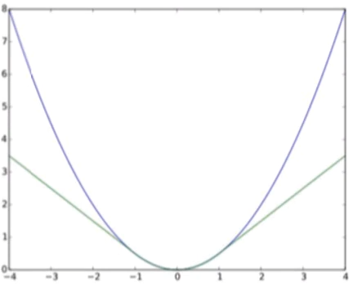
Huber Loss is used instead of squared loss. Unlike squared loss (A parabola), after a certain point, huber loss becomes linear. Outliers have less impact.

There’s an upward bias in taking the max action from the output of a Q-function. If an action was randomly initialized higher, it could be erroneously favored.

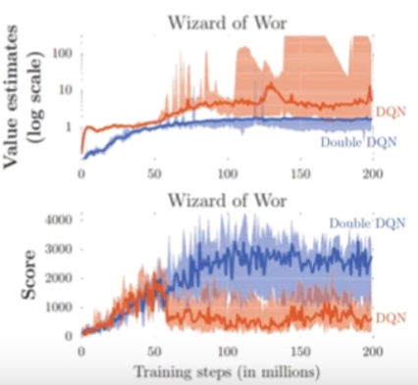
This bias is solved by using Double DQN. We already have two sets of weights, so we take the max action of the first and use the second to evaluate that action.

Prioritized Experience Replay:
Some memories are more valuable than others.
Track the Bellman error of training on memories: the difference between the target value and the Q-value output.
Prioritize higher bellman errors.

Pieter Abbeel 3: Policy Gradients and Advantage Estimation
L3 Policy Gradients and Advantage Estimation (Foundations of Deep RL Series)

Alternative methods for solving MDPs.

DQN is very data efficient but less stable than other methods. If you have tons of data (eg. simulation), you can use a less data efficient method but get an overall faster result.

Policy Optimization: Distribution of actions.

Q-learning doesn’t efficiently take the max action in a high-dimensional action space.
Value learning requires a more complicated reward function. Again, difficult in high-dimensional action spaces.

Tau = state-action sequence. Utility = expected sum of rewards.

Likelihood Ratio Policy Gradient:
Computing gradients with respect to the expected future rewards allows you to create a simpler reward function. Eg. only reward on win.
Increase probability of trajectories with high reward and decrease for trajectories with low reward. “Trajectory” is important. Probabilities integrate to 1, so pushing up in one place pushes everything else down.

Sigma Symbol = sum sequence

Theta (distribution of output actions) doesn’t appear in the dynamics model, only in the policy. So, to train the policy model you don’t need a dynamics model. You can train without a model of the world.

To make the output of this less noisy, we can subtract out the average reward value of X iterations, now we have a baseline. This works with finite samples, it generates a better gradient estimate. Can also use weighted average, etc.

Value Function Estimation:
Supervised learning with rewards of state-action pairs.

Advantage Estimation:
Variance is reduced by discounting some iterations. Critic.
Actions have more impact short-term than long-term, so you can discount long-term rewards.
Advantage estimate is the difference between the observed return and baseline.

Bias and variance are the tradeoff. Eg. if you take the discounted sum of rewards of 2 actions vs. 5, you get higher bias at lower actions but lower variance.?

A3C collects new data for every new policy iteration, DQNs have to use memories of old policies to train on.

Pieter Abbeel 4: TRPO and PPO
L4 TRPO and PPO (Foundations of Deep RL Series)

Under supervised learning, if you have a bad step size, the next iteration will correct for it. You have labels.
Under reinforcement learning, a bad step size derails data collection (need good actions to train on).

An expensive solution is line search. Eg. try a few different step sizes and see which is best.

Trust Region Policy Optimization:
Instead of just computing a gradient, take a loss function.
Advantage is computed based on the old policy, so you can’t take too large a step.
TRPO makes it difficult to implement dropout or parameter sharing between policy and value function. It also can’t use first-order optimizers like Adam, RMSProp.

Proximal Policy Optimization:
TRPO is a constraint problem (can’t take too large of a step). PPO is a reorganized equation that makes it an optimization problem.

PPO is the most efficient reinforcement learning method.

Pieter Abbeel 5: DDPG and SAC
L5 DDPG and SAC (Foundations of Deep RL Series)

DDPG and SAC do multiple gradient optimizations on the same data, so they’re more sample efficient.

Soft Actor Critic (SAC) is the maximum entropy version of Deep Deterministic Policy Gradient (DDPG).

Deep Deterministic Policy Gradient:
Noise can be added during rollouts to increase exploration.
In the Policy Update, you backpropagate through Q to compute gradient estimates for all samples.

Soft Actor Critic:
DDPG can be unstable, SAC solves this by adding entropy of policy to the objective.

Pieter Abbeel 6: Model-based RL
L6 Model-based RL (Foundations of Deep RL Series)

Everything so far has been model-free reinforcement learning. Just learning a Q-function for an agent to use when navigating the world.
The alternative is learning a dynamics model/world model. This allows you to be more sample efficient by finding a good policy by using the world model.

Use your data to learn a model, then use that model to learn a Q-function.

The policy is trained either by backprop-through-time or using the learned model as a simulation.

Learning a model means you can reuse it for other tasks assuming it’s general enough.

If you already have a simulator (eg. Atari) then model learning is sometimes not used.

Over-fitting = performing well on training data but poorly on test data.

Model-bias = Policy optimization exploiting regions where there is insufficient data to train the model. Catastrophic failures in testing. Erroneous rewards in training that don’t exist in the real world.

Model-Ensemble Trust Region Policy Optimization (ME-TRPO) is the solution to model-bias. Train multiple models simultaneously (world models), disagreement means there isn’t enough data.

Model-based Meta-policy Optimization. This learns an adaptive policy that can quickly adapt to new environments. MB-MPO has asymptotic performance similar to model-free methods.

All methods except the full deterministic ones for MDPs at the beginning of this lecture series and Approximate Methods.

Policy Gradient methods are better for fast simulations/data collection.

